

Project Design Phase-II
Data Flow Diagram & User Stories

Date | 15 July 2026
Team ID | SWTID-2026-7507
Project Name | Darshan Ease
Maximum Marks | 4 Marks

Data Flow Diagrams:
A Data Flow Diagram (DFD) is a traditional visual representation of the information flows within a system. A neat and clear DFD can depict the right amount of the system requirement graphically. It shows how data enters and leaves the system, what changes the information, and where data is stored.

Darshan Ease:DFD Level 1 (Detailed)

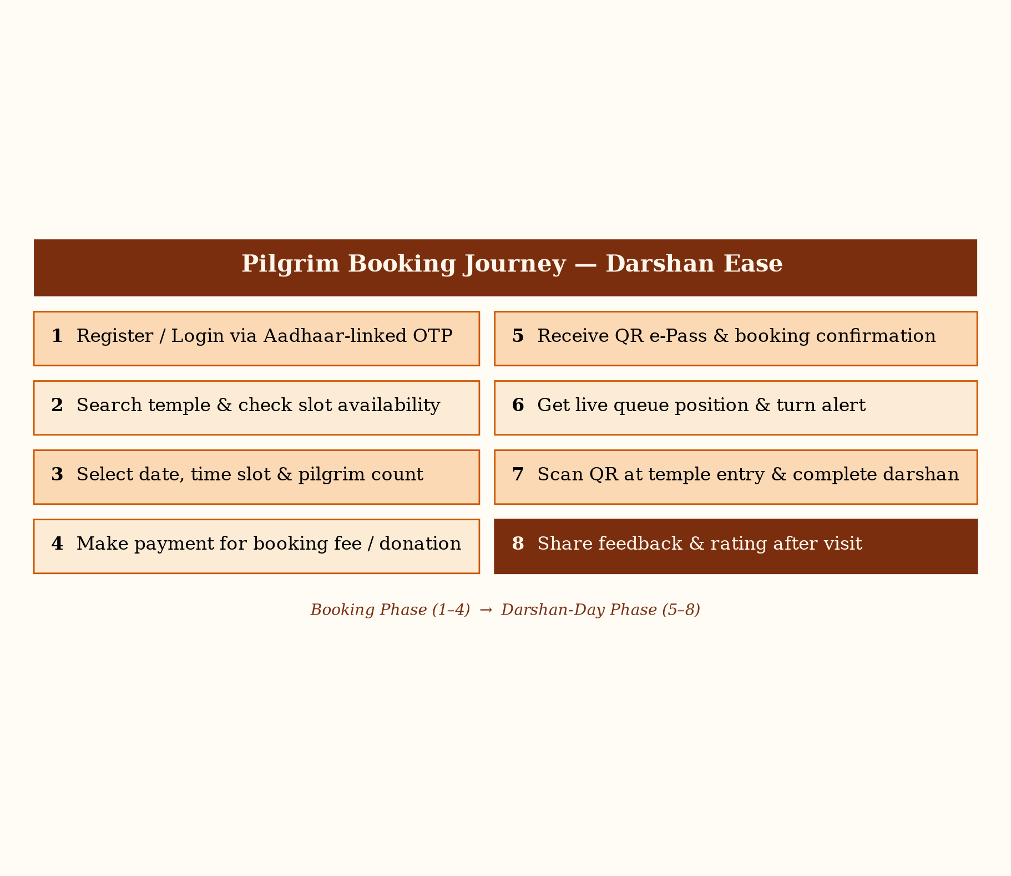

User Stories
Use the below template to list all the user stories for the product.
User Type | Functional Requirement (Epic) | User Story Number | User Story / Task | Acceptance criteria | Priority | Release
Customer (Mobile user) | Registration | USN-1 | As a pilgrim, I can register using my mobile number and verify via Aadhaar-linked OTP. | I can access my dashboard after successful OTP verification | High | Sprint-1
 |  | USN-2 | As a pilgrim, I can register using my email and password. | I receive a confirmation email and can log in | Medium | Sprint-1
 | Login | USN-3 | As a pilgrim, I can log in using my registered mobile number and OTP. | I can access my dashboard after OTP verification | High | Sprint-1
 | Slot Booking | USN-4 | As a pilgrim, I can search for a temple and view available darshan slots. | I can see slot timings and remaining capacity | High | Sprint-1
 | Slot Booking | USN-5 | As a pilgrim, I can select a date, time slot and number of pilgrims, and book the slot. | I receive a booking confirmation and QR e-pass | High | Sprint-2
 | Queue Status | USN-6 | As a pilgrim, I can view my live queue position and estimated wait time. | I receive a turn alert notification when my turn is near | Medium | Sprint-2
Customer (Web user) | Payment | USN-7 | As a pilgrim, I can pay the booking fee or make a donation online. | Payment is confirmed and reflected in my booking status | High | Sprint-2
 | Prasad Order | USN-8 | As a pilgrim, I can order prasad for home delivery after booking. | I receive an order confirmation with delivery tracking | Low | Sprint-3
Customer Care Executive | Support | USN-9 | As a customer care executive, I can view and resolve pilgrim support tickets. | Ticket status is updated and the pilgrim is notified | Medium | Sprint-3
 | Feedback | USN-10 | As a customer care executive, I can view pilgrim feedback and ratings after darshan. | Feedback is logged against the booking record | Low | Sprint-3
Administrator | Slot Management | USN-11 | As an administrator, I can configure darshan slot capacity and schedule. | Updated slots are reflected instantly for pilgrims | High | Sprint-1
 | QR Validation | USN-12 | As an administrator, I can scan and validate a pilgrim's QR e-pass at the temple entry. | Valid passes grant entry and mark the booking complete | High | Sprint-2

